Name : S Hari Prasath
REG NO : 192512041
EX NO: 1 – Butterworth IIR Filters
DATE: 23/07/2026
1.1. Design and Analysis of a Butterworth IIR Low-Pass Filter Using MATLAB.
Objectives
- To determine the minimum filter order and cutoff frequency, required to satisfy the design constraints.
- To design and analyze the magnitude response, phase response, characteristics of the Butterworth IIR low-pass filter for the given passband and stopband specifications.
- To analyze the impulse response, step response and group delay characteristics of the Butterworth IIR low-pass filter for the given passband and stopband specifications.
- To examine the pole-zero plot and verify the stability and performance of the designed low-pass filter.
Procedure
- Open MATLAB and create a new script file in the MATLAB Editor.
- Define the filter specifications such as passband ripple (Rp), stopband attenuation (Rs), passband frequency (Fp), stopband frequency (Fsb), and sampling frequency (Fs).
- Calculate the normalized passband and stopband frequencies with respect to the Nyquist frequency (Fs/2).
Program Code:
clc;
clear;
close all;

Fs = 10000;
Fp = 1000;
Fst = 1500;

[N,Wn] = buttord(Fp/(Fs/2),Fst/(Fs/2),1,60);
[b,a] = butter(N,Wn);

% Frequency Response
figure;
freqz(b,a);

% Impulse Response
[h,n] = impz(b,a,50);
figure;
stem(n,h,'filled');
grid on;
xlabel('Samples');
ylabel('Amplitude');
title('Impulse Response');

% Step Response
figure;
stepz(b,a);

% Pole-Zero Plot
figure;
zplane(b,a);

fprintf('Minimum Filter Order (N) = %d\n',N);
fprintf('Cutoff Frequency (Wn) = %.4f\n',Wn);

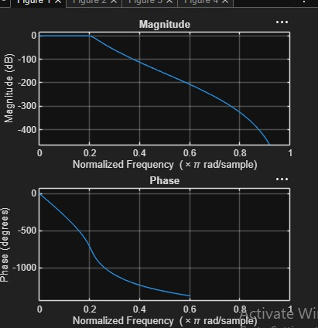
OUTPUT AND RESULT:
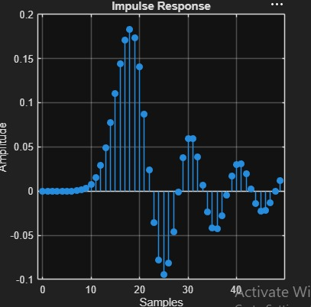
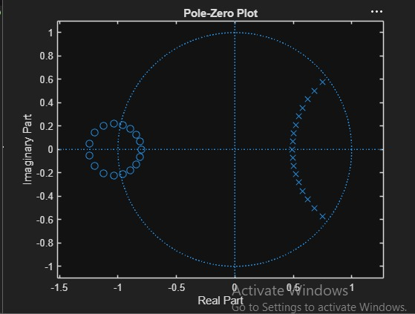
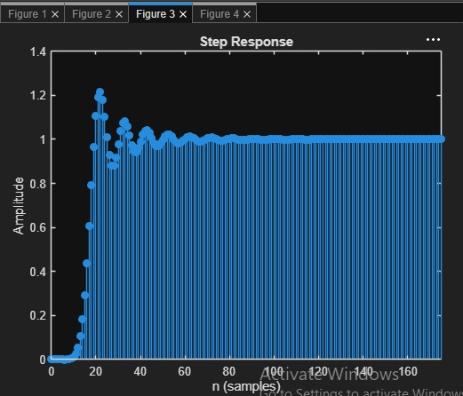
Fig 4
Fig 3
Fig 2
Fig 1

Result:
1.The minimum filter order and cutoff frequency satisfying the given specifications were
determined successfully.
2.The magnitude and phase responses of the Butterworth IIR low-pass filter were obtained and
analyzed.
3.The impulse response, step response, and group delay characteristics were evaluated
successfully.
4. The pole-zero plot confirmed the stability and proper performance of the designed filter.

